ASSINGMENT 1 :- SOFTWARE ENGINEERING

Q1. What is software? What is software engineering?

A1. The software is a collection of programs organized by instructions and code written by developers on any of various particular computer languages.

Software engineering is defined as a process of analyzing user requirements and then designing, building, and testing software application which will satisfy those requirements. It is a systematic and disciplined approach to software development that aims to create high-quality, reliable, and maintainable software.

* The main goal of Software Engineering is to develop software applications for improving quality,  budget, and time efficiency.

Q2. Explain types of software ?

A2. There are various type of software from which some are listed as below :-

1. **System Software**: This includes operating systems (like Windows, macOS, Linux) that help manage and integrate a computer's resources and provide a platform for application software.
2. **Application Software**: These are programs that perform specific tasks for users (such Microsoft suit, game and utility software).
3. **Programming Software:** This software is also called a programming tool or software development tool used by developers to write code.( Like Python, Java, C++, and JavaScript).
4. **Middleware:** Facilitates communication between applications and databases, managing queries and data exchange. (Like Apache HTTP Server , Nginx , Oracle WebLogic and Apache Kafka).
5. **Freeware:** Software that is available for use at no cost (Like Skype and Adobe Acrobat Reader)
6. **Utility Software:**This type of application software is used to support the computer infrastructure. It is designed to analyze, configure, optimize and maintains the system (Like Antivirus and memory tester).

Q3. What is SDLC? Explain each phase of SDLC.

A3. **Software Development Life Cycle (SDLC)** is a structured process used by software engineers and developers to design, develop, test, and deploy software.

The phases of SDLC Are Explained As Below :-

1. **Planning :** The first stage of the SDLC is planning. The purpose of this stage is to develop a basic plan about what an application needs to do based on user requirements.
2. **Define Requirements :** This phase is critical for converting the information gathered during the planning and analysis phase into clear requirements for the development team.
3. **Designing:** It focuses on deciding how the application behaves and what it looks like from the user's perspective. The original plan and vision are elaborated into a software design document (SDD) that includes the system design, programming language, templates, platform to use, and application security measures.
4. **Development or Building:** The design is then implemented in code, usually in several iterations, and this phase is also called as Development.

* This phase consists of Front end + Middleware + Back-end.

1. **In front-end:**Development of coding is done even SEO settings are done.
2. **In Middleware:** They connect both the front end and back end.
3. **In the back-end:** A database is created.
4. **Testing:** It identify and fix defects in the software to ensure it meets the specified requirements.

The types of testing to do in this phase:

* **Performance testing:**Assesses the software's speed and scalability under different conditions
* **Functional testing:**Verifies that the software meets the requirements
* **Security testing:**Identifies potential vulnerabilities and weaknesses
* **Unit-testing:**Tests individual units or components of the software
* **Usability testing:**Evaluates the software's user interface and overall user experience
* **Acceptance testing:**Also termed end-user testing or beta testing is the final testing stage to test if the software product delivers on what it promises

1. **Deployment:** Deployment is the stage where the application moves into a production environment, where it is accessible to end users.
2. **Maintenance:**This is the final phase that includes ongoing support, bug fixes, and updates to the software.

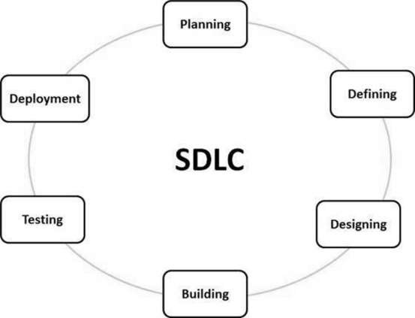

Q4. What is DFD? Create a DFD diagramon Flipkart

A4. Data Flow Diagram (DFD) represents the flow of data within information systems and represents how data moves from input to output in graphical representation that can be understood by both technical and non-technical users.

DFD diagram for Flipcart :-

USER -----> REGISTRATION

---------- --------------------

PRODUCT SEARCH ------> PRODUCT CONFIRM

------------------------ --------------------------

PAYMENT PROCESS <------- PAYMENT METHOD

------------------------- -------------------------

Q5. What is Flow chart? Create a flowchart to make addition of two numbers.

A5. Flowcharts are nothing but the graphical representation of the data or the algorithm for a better understanding of the code visually. It uses a combination of symbols, shapes, and arrows to illustrate the steps involved in a process and the sequence in which these steps occur.

FLOWCHART TO MAKE ADDITION OF TWO NUMBERS IS AS FOLLOWS :-

**START**

**SUM = NO.1+NO.2**

**INSERT N0.1 AND NO.2**

**PRINT SUM**

**END**

Q6. What is Use case Diagram? Create a use-case on bill payment on paytm.

A6. It serves as a blueprint for understanding the functional requirements of a system from a user’s perspective . The diagram shows the relationships between the actors and the use cases in which they are involved, making it easier to understand the functionalities that the system provides and how users will interact with it.

USE CASE ON BILL PAYMENT ON PAYTM:-

USER -------> REGISTRATION

LOGIN

-----------------

PAYMENT TYPE

--------------------

BILL DETAILS

-------------------

PAYMENT METHOD

--------------------------

PAYMENT GATEWAY

-------------------------

PAYMENT PROCESS

-------------------------

PAYMENT CONFIRMATION .